Originally written by: Jenna Celius and Cathy Kollar
VolunteerHub User’s Guide
Contents
1 Editing Your Event Details 3
2 Removing a User from an Event in Volunteer Hub 4
3 Volunteer Hub Reports 5
3.1 Event Registrations Report 5
4 Sign-In Sheets 7
5 Recording Attendance and Hours After Your Event 8

1 Editing Your Event Details
- Log in to http://phs.volunteerhub.com with your DRIVER account
- Select Admin
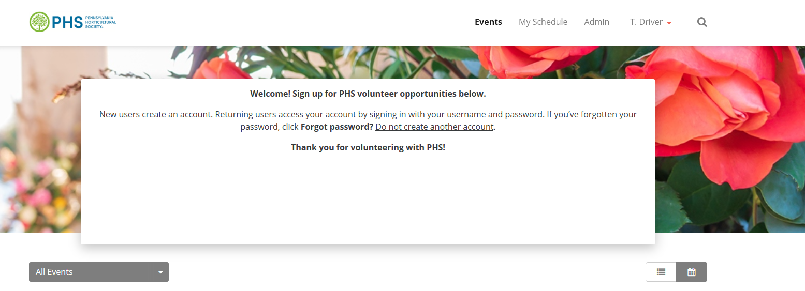
- Click on your Tree Tender group event
- Click Edit to change your event details
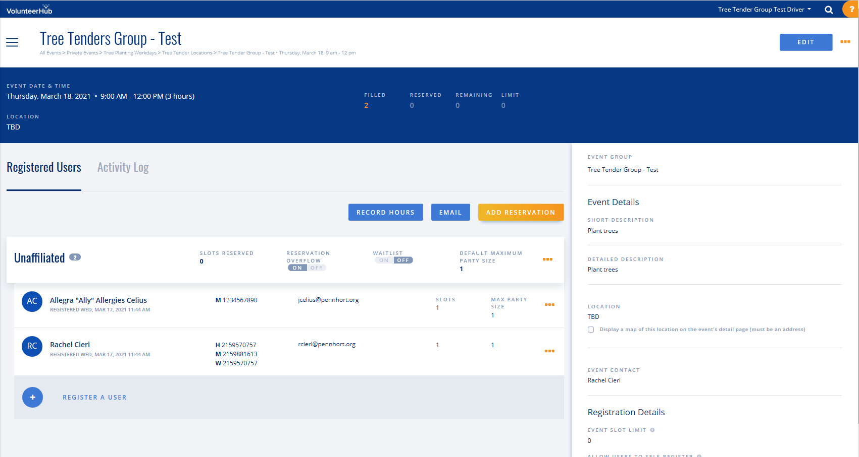
- Please do not change the Event Group, the Waiver, Self-Registration, Event Visibility, and the Hours Self-Reporting.
- Change the Short Description and Long Description if applicable.
- Change the Event Slot Limit if applicable (capacity of volunteers needed for your event).
- Change the Self-Registration and Self-Cancellation cut-off if applicable. You may choose a time from the drop-down that means Users cannot sign-up or cancel from your event in that time before your event. For example, if you choose 2 weeks for both, that means Users cannot sign-up or cancel 2 weeks before your event.
- Change Confirmation Message if applicable (what volunteers get automatically when they sign up for your event). You may click send Confirmation email and cancellation email to Event Contact to get emails of the individual volunteers that sign up and cancel.
- Add Thank You email language if applicable. Please Note: The volunteers will not get this message unless they have their hours recorded within 24 hours. It is not mandatory.
- Once you are done, scroll back up to the top and click Save.

2 Removing a User from an Event in Volunteer Hub
- Log in to Volunteer Hub using your DRIVER account
- Select ADMIN
- Click on your Tree Tender Event
- Click on the 3 dots at the end of the row of the User that you are removing
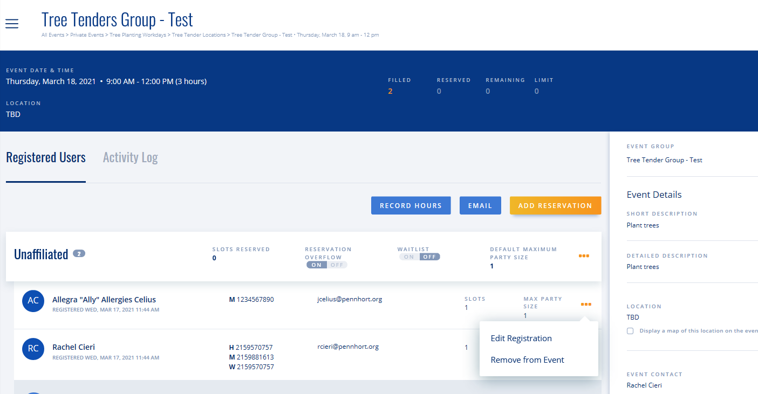
- Click Remove from Event

3 Volunteer Hub Reports

After logging into VolunteerHub
- Select ADMIN
- Select the button next to Dashboard
- Select Reports – You can manage volunteers using the following reports:
  - In Unformatted Reports tab
    - Event Registration Report
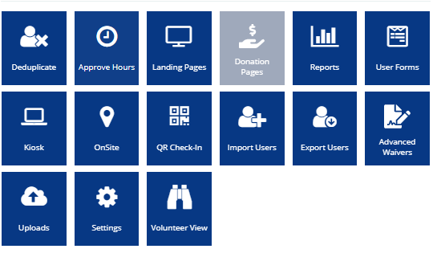

3.1 Event Registrations Report
This report will generate a spreadsheet with participant contact and participant event information. This will be useful if you need contact information as well as to see if the PHS Covid-19 Waiver has been acknowledged.

- In the Unformatted Reports tab, select Event Registrations Report
- 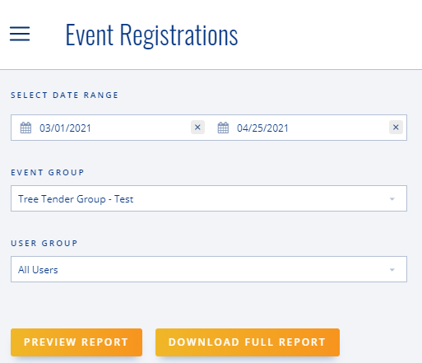
  - Change the date range. You can generate a report for 1 day or a range of dates by entering a single day or a date range
  - Click the Event Group box to show the list of volunteer jobs that you can report on. Select the volunteer job for which you want a report.
  - Always use “All Users” as your User Group.
    - Important- Using All Users is the only way to get an accurate report of all your signups.
  - Click the Preview Report button
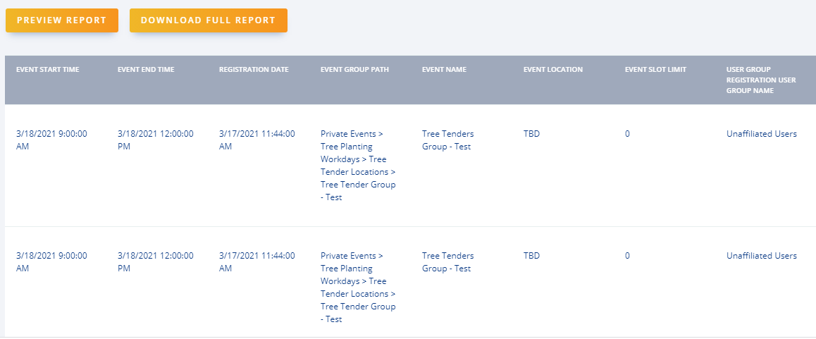
  - To open the report in a spreadsheet:
    - Select Download Full Report

4 Sign-In Sheets
Here is a way to create the sign in sheet from the Event itself.
- Log in to Volunteer Hub using your DRIVER account
- Select ADMIN
- Select Event
- At the top of the page, click the orange button next to Edit
- In the drop-down menu, click either Open Sign-In Sheet for PDF file or Export Sign-In Sheet for Excel file.
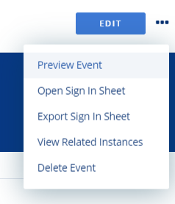
Excel
PDF
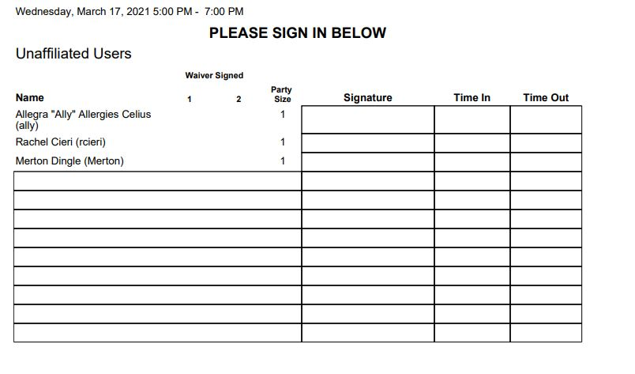

5 Recording Attendance and Hours After Your Event
- Log in to Volunteer Hub using your DRIVER account
- Select ADMIN
- Select Event
- Filter by the date and Event Group of your event
- Click your event
- Select Record Hours
- Enter the number of hours worked next to each volunteer name
- Click Save
- Please note- To receive an automatic Thank You email, hours must be added within 24 hours of the Event

