Getting ready for your new tree(s)!
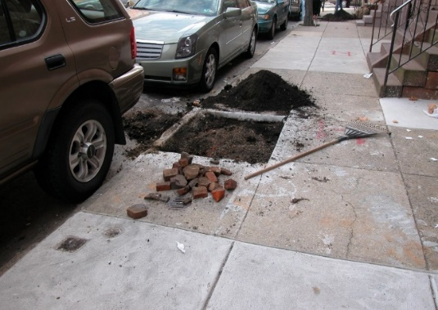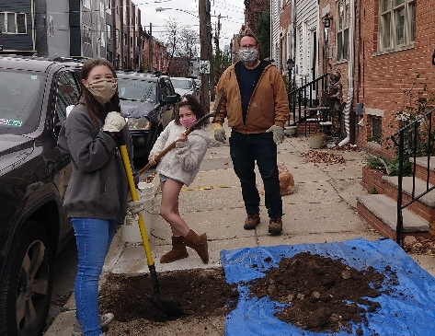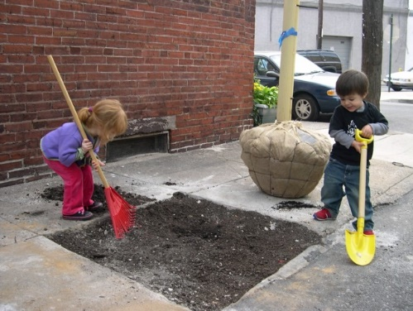
What to do before planting day…
- Clean site of grass, weeds, debris, and rocks prior to planting day. Discard turf if planting in a grass in a 3-foot ring where the tree will be planted.
- If possible, dig your hole a 3-foot diameter but DO NOT DIG DEEPER THAN 6 INCHES. The tree roots are often shallow, and we want to avoid planting it too deep. If planting in a cutout in the sidewalk, dig out the entire area of the opening (out to the corners) to loosen the soil and then backfill. Tip: use a tarp or large bin to put the soil on for easier cleanup.
- Make sure that the soil is filled back up to sidewalk/soil grade so that a tripping hazard is not created. If the site does not appear safe, please put a trash can or other item in the pit to prevent people from walking into it and potentially tripping.
- If you find any large obstacles in the tree pit when you are digging, let us know as soon as possible.
- Make a watering plan - will you use a hose or a bucket? please have your system ready to go for planting day.

What to do on planting day…
- Plan to be there, and available.
- Wear a mask, practice social distancing of at least 6ft with people not in your household/work group, and have sanitizer available.
- Have water available for your tree (and the planters too if possible). Water your tree as soon as it is planted and then twice a week for the first month. 10-15 gallons of slow watering is best. After the first month, water once a week until the ground freezes and then again when the ground thaws or at the first sign of buds opening in the spring!
- Ask questions about caring for your tree and what to expect…. There is a saying that for a newly planted tree,
“the first year it sleeps, the second year it creeps and the third year it leaps!” Check out PHS tree planting and care videos at https://phsonline.org/programs/tree-programs/for-current-tree-tenders.
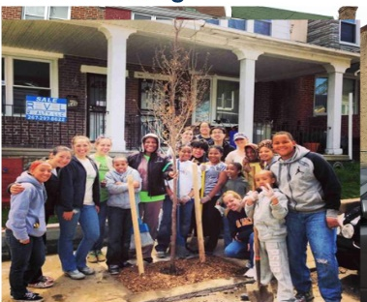
- Name and enjoy your new tree!

